Josiah Silverberg
Professor Sanchez
Special Topics in Cybersecurity
December 15, 2025

CTF Writeups
NCL-Team games
Reconnaissance
- First 3 tasks were about ports: the lowest open, highest open, and all unique ports. To find this, I ran NMAP in the command line 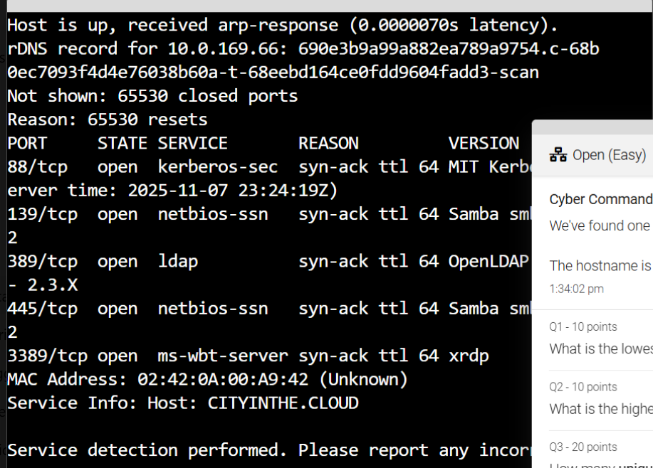Through this, I was able to discover 88 as the lowest, 3389 as the highest with 4 unique entries. It also answers question 4, as it uses Samba, the Linux version of SMB.
Log Analysis
- First question was to find the hostname, which I simply searched for User and found the name of the hostname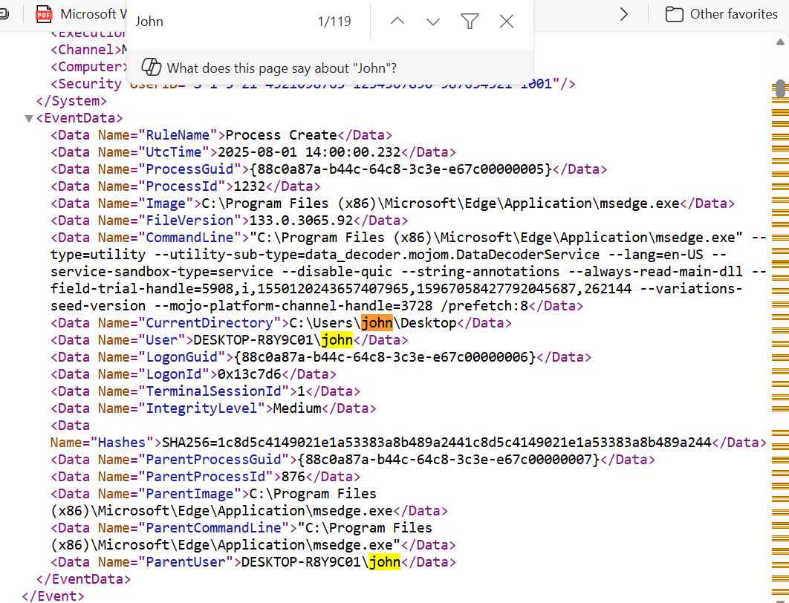
I also needed to find the link that was clicked on that let the malware in, and what process allowed it. 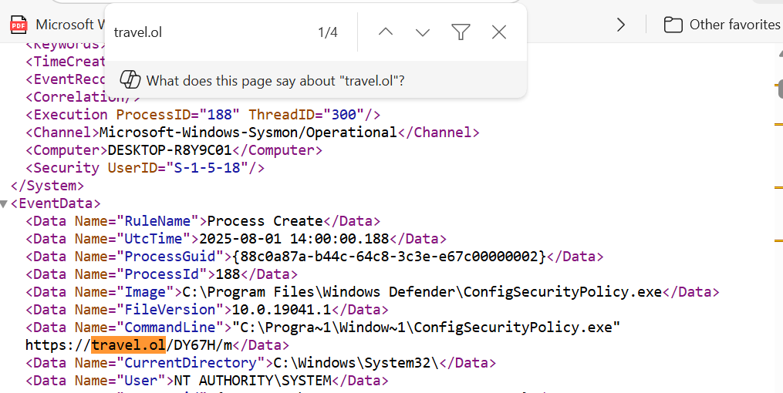
The process seems to be ConfigSecurityPolicy.exe that activated, and launched the URL which held the malicious code.
There was also an inquiry about the computer name, which I searched for Desktop and found it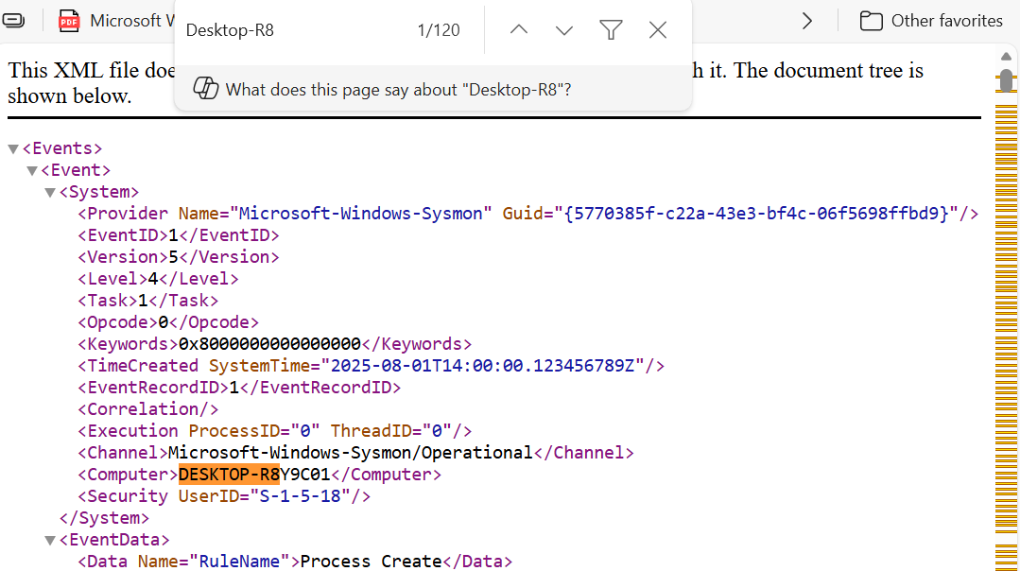
Forensics
- For this one, I was only able to solve one problem: I used a hexdump to get some binary information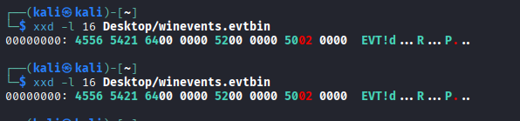
The first 4 bytes = EVT!, which was the answer
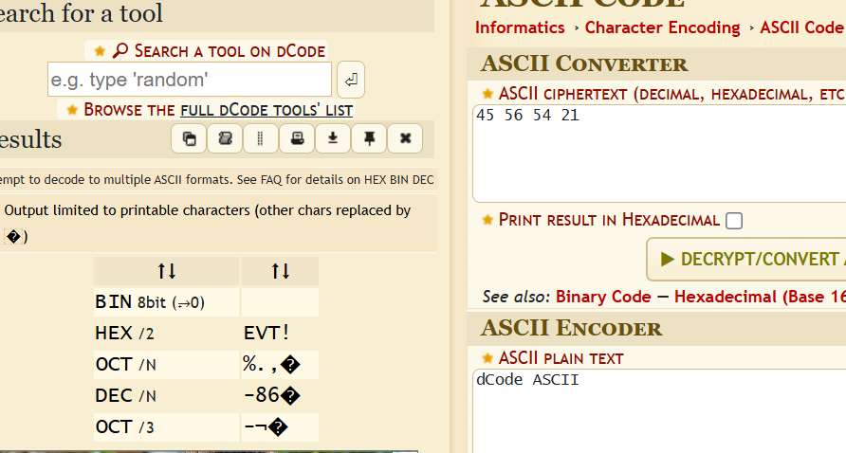
Enumeration
- First question asked for the name of the malicious image file. Using the jq tool (awk for .json), I was able to extract a gif file, “merch.gif” which was the answer.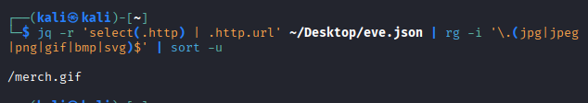
Next, I needed to find the victim IP most connected to. Using a combination of jq (again, a json awk) , sort(to get numerical order) and head to get the most prominent, I was able to discover the top IP address victimized. 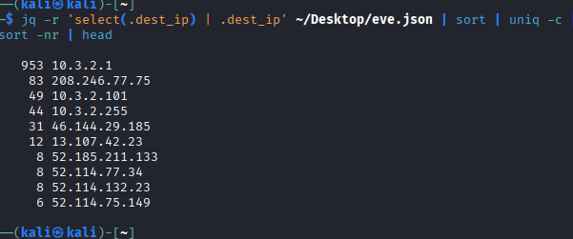
10.3.2.1 was an internal address, so the correct answer was 208.246.77.75

Next, the question was to find the two “event types” utilized in the C2 connection. For this, I used the victimized IP (204.246…), then checked its event types, and got flow and tls.

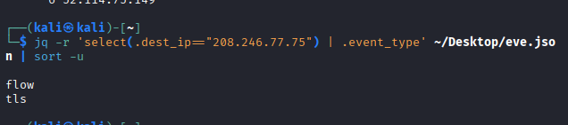

The next task was to find the fully qualified domain name of the suspicious domain the attacker connected to. To find this, I entered this command:
(jq -r --arg ip "10.3.2.101" '
select(.src_ip==$ip and (.event_type=="dns" or .event_type=="tls" or .event_type=="http")) |
(.dns.rrname // .dns.qname // .http.host // .tls.sni // .tls.server_name // empty)
' ~/Desktop/eve.json | sort -u)
And got a string of results (101.2.3.10.in-addr.arpa 1.2.3.10.in-addr.arpa 2.3.10.in-addr.arpa activity.windows.com arc.msn.com cannonlightingllc.com cannonlights-dc.cannonlightingllc.com Cannonlights-DC.cannonlightingllc.com CANNONLIGHTS-DC.cannonlightingllc.com client.wns.windows.com config.edge.skype.com continuum.dds.microsoft.com ctldl.windowsupdate.com DESKTOP-PDK9T4A.cannonlightingllc.com dns.msftncsi.com fe2cr.update.microsoft.com fe3cr.delivery.mp.microsoft.com _ldap._tcp.dc._msdcs.CANNONLIGHTING _ldap._tcp.dc._msdcs.CANNONLIGHTING.cannonlightingllc.com _ldap._tcp.Default-First-Site-Name._sites.cannonlightingllc.com _ldap._tcp.Default-First-Site-Name._sites.dc._msdcs.cannonlightingllc.com _ldap._tcp.Default-First-Site-Name._sites.DomainDnsZones.cannonlightingllc.com _ldap._tcp.Default-First-Site-Name._sites.ForestDnsZones.cannonlightingllc.com _ldap._tcp.pdc._msdcs.cannonlightingllc.com login.live.com login.microsoftonline.com logon.secure.xyz nexusrules.officeapps.live.com pti.store.microsoft.com self.events.data.microsoft.com settings-win.data.microsoft.com storeedgefd.dsx.mp.microsoft.com v10.events.data.microsoft.com v20.events.data.microsoft.com watson.telemetry.microsoft.com wpad.cannonlightingllc.com www.bing.com wxnmnmfmawzyaz.cannonlightingllc.com)

With logon.secure.xyz being the suspicious domain.

The last question asks for the serial number that identifies that domain.
To solve this, I inspected logon.secure.xyz for clues for its certificate. I entered :

(jq -r --arg d "logon.secure.xyz" \
'select(.event_type=="tls" and (.tls.sni==$d or .tls.server_name==$d)) | .tls.server_cert.serial // .tls.server_cert[0].serial // empty' \
~/Desktop/eve.json | sort -u)

And got to this page.

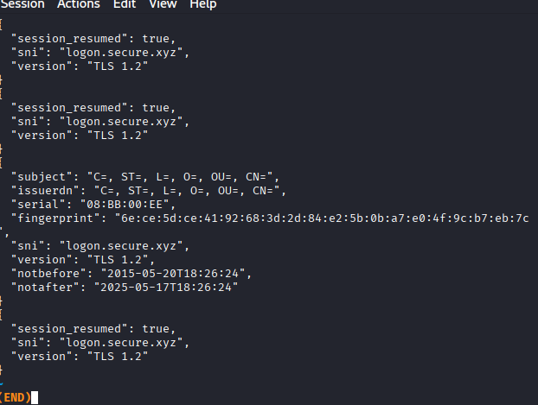
This tells us the serial number that identifies the certificate, which was 08:BB:00:EE.

